EXP NO – 13

Create a Virtual Machine with 1 CPU, 2 GB RAM and 15 GB Storage Disk using Type-2 Virtualization Software
Aim:
To create and configure a Virtual Machine using VMware Workstation (Type-2 Hypervisor) with 1 CPU, 2 GB RAM and 15 GB virtual hard disk.

Procedure
Step 1: Open VMware Workstation and click Create a New Virtual Machine.
Step 2: Select Linux as the Guest Operating System and choose Ubuntu.
Step 3: Allocate 2 GB (2048 MB) memory to the virtual machine.
Step 4: Configure the processor with 1 CPU and 1 core.
Step 5: Create a virtual hard disk with a capacity of 15 GB.
Step 6: Review the configuration and save the virtual machine.
Step 7: Power on the virtual machine to verify successful configuration.

1. Selecting Guest Operating System

2. Selecting Memory (2 GB)
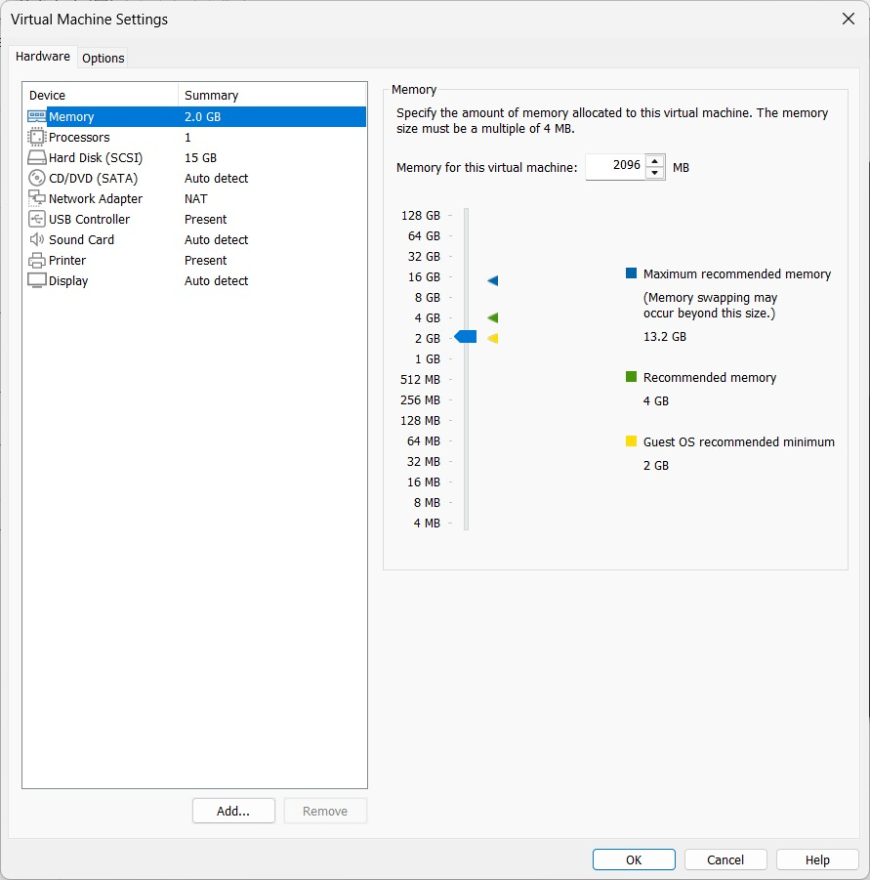

3. Selecting Processor (1 CPU)
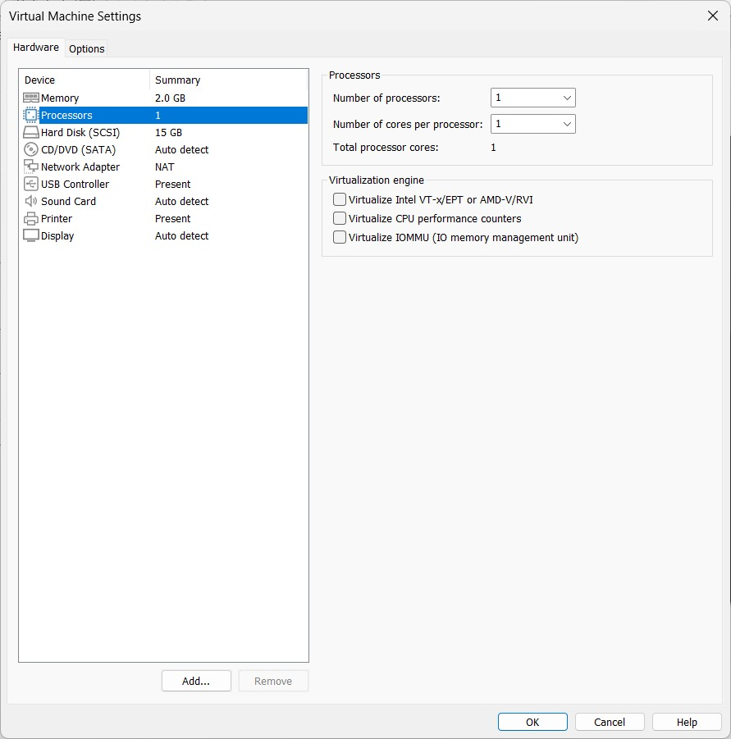

4. Configuring Hard Disk (15 GB)
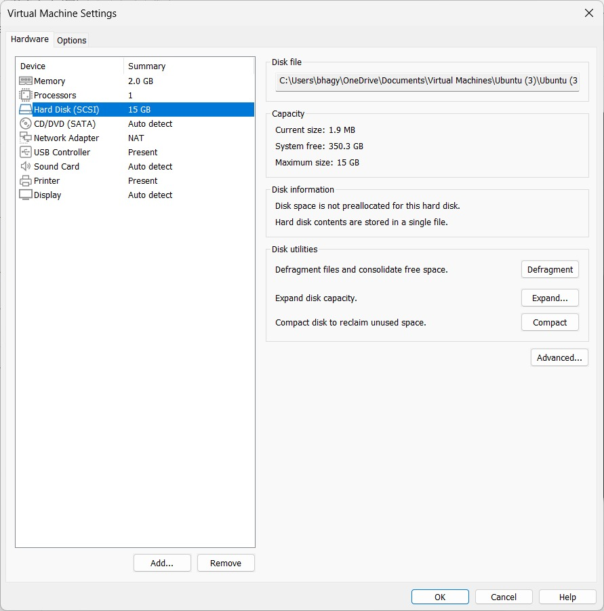

Observation
The virtual machine was successfully configured with 1 CPU, 2 GB RAM and a 15 GB virtual hard disk using VMware Workstation. The VM settings reflected the configured hardware resources correctly.

Result
Thus, a Virtual Machine was successfully created and configured using a Type-2 Hypervisor (VMware Workstation) with 1 CPU, 2 GB RAM and 15 GB storage disk.

